mslogo-1.jpg

Windows 7 Software Logo Toolkit  
User’s Guide

Published April 2009  
Updated Aug 2009

#### **For the latest information visit:** [**http://go.microsoft.com/?linkid=9658452**](http://go.microsoft.com/?linkid=9658452)

The information contained in this document represents the current view of Microsoft Corp. on the issues discussed as of the date of publication. Because Microsoft must respond to changing market conditions, it should not be interpreted to be a commitment on the part of Microsoft, and Microsoft cannot guarantee the accuracy of any information presented after the date of publication.

This guide is for informational purposes only. MICROSOFT MAKES NO WARRANTIES, EXPRESS OR IMPLIED, IN THIS SUMMARY.

Complying with all applicable copyright laws is the responsibility of the user. Without limiting the rights under copyright, no part of this document may be reproduced, stored in or introduced into a retrieval system, or transmitted in any form, by any means (electronic, mechanical, photocopying, recording or otherwise), or for any purpose, without the express written permission of Microsoft.

Microsoft may have patents, patent applications, trademarks, copyrights or other intellectual property rights covering subject matter in this document. Except as expressly provided in any written license agreement from Microsoft, the furnishing of this document does not give you any license to these patents, trademarks, copyrights, or other intellectual property.

Unless otherwise noted, the example companies, organizations, products, domain names, e-mail addresses, logos, people, places and events depicted herein are fictitious, and no association with any real company, organization, product, domain name, e-mail address, logo, person, place or event is intended or should be inferred.

© 2009 Microsoft Corp. All rights reserved.

# How to Use This Document

This document summarizes the requirements of the Windows 7 Software Logo Program, and describes how to use the Windows 7 Software Logo Toolkit to test applications and verify their compliance against the program’s requirements.

The Windows 7 Software Logo Toolkit provides is a command line utility that can be used to determine if an application meets the requirements of the Windows 7 Software Logo Program. The purpose of this document is to enable a tester to configure an environment suitable for running the Windows 7 Software Logo Toolkit, and to provide detailed step-by-step instructions for using it to verify an application’s compliance. Many steps are self-explanatory, but where more detail is necessary, a step is broken down into a list of sub-steps for clarification.

# Windows 7 Software Logo Program Requirements

To participate in the Windows 7 Software Logo Program, an application must meet the following requirements:

1. The application must implement a clean, reversible installation. The application must be able to roll back the installation if a failure occurs and restore the computer to its previous state.
2. The application must install to the correct folders by default:

* Applications must be installed to the Program Files folder (or the Program Files (x86) folder for 32-bit applications).
* Shared application data must be installed to the %ProgramData% folder.
* Private data specific to a user must be installed to the user’s %AppData% folder.
* The application must not write to the Windows folder or any of its sub-folders, with the possible exception of the global assembly cache.

1. All executable files must be digitally signed with an Authenticode signature. All kernel-mode drivers installed by the application must include a Microsoft signature obtained through the WHQL or DRS programs.
2. The application must install and run under the 64-bit version of Windows 7. 32-bit applications must run and install seamlessly on the 64-bit version of Windows 7.
3. Applications must not be blocked from execution or install based on specific version of the operating system. Applications written for Windows XP or later should not fail due to a check of the operating system version.
4. Applications must follow User Account Control (UAC) guidelines and avoid exposing the system to security risks.
5. Applications must adhere to Windows Restart Manager Messages. Applications must not block operating system shutdown requests.
6. Applications must not load services and drivers in Safe Mode.
7. Applications must support concurrent user sessions without causing conflict or disruption, or impacting the functionality of the application. User privacy and preferences must be isolated inside the user’s session.

For detailed information about these requirements, see the Windows 7 Client Software Logo Requirements document <http://go.microsoft.com/?linkid=9630189>

# 

# Overview of the Software Logo Command Line Toolkit

The toolkit takes a snapshot of the state of the computer at various stages during install and uninstall of an application, it also manipulates the application at runtime. The toolkit builds an inventory of files, registry key, and other elements at each stage. It uses this inventory information to track changes the application made when it was installed and after it was uninstalled. The toolkit then ascertains whether the application conforms to the requirements of the Windows 7 Software Logo Program. The toolkit generates a report listing the details of any areas where the application does not comply with the requirements.

**Configuring a Test Environment**

You must perform all tests on a computer that is running a clean installation of Windows 7 Ultimate. Configure and install the Windows 7 Software Logo Toolkit as described in this section. Apart from the application being tested, do not install additional applications or utilities such as antivirus software or a third-party firewall, as they may taint the outcome of the tests.

#### Note**:** You may want to run Windows 7 in virtual environment such as Windows Hyper-V, Virtual Server, or Virtual PC and save snapshots of the virtual machine after you have installed the Windows 7. This will allow you to quickly restore a clean Windows 7 environment to test multiple applications or repeat any tests as needed.

## Minimum System Requirements

Your system must meet the following minimum requirements:

* 1GHz 64bit (x64) processor
* 1Gb RAM
* 40Gb hard drive
* Windows 7 Ultimate, 64-bit

## Configure Windows 7 Ultimate and Install the Windows 7 Software Logo Toolkit

* Perform a default installation of Windows 7 Ultimate.

#### Note: Install Windows 7 using the specified language for the application. If the application is language-neutral, you must not install any additional language packs.

#### All tests in this document assume that Windows 7 is installed on the C: drive.

* Log on to Windows 7 using an account with administrator privileges.
* Download the Windows 7 Software Logo Toolkit (Logo Test Tool.msi) from the Windows 7 Software Logo Program Web site at https://connect.microsoft.com/site/sitehome.aspx?SiteID=831
* Install the Windows 7 Software Logo Toolkit:

1. Start the Logo Test Tool.msi installer. If the **Open File – Security Warning** dialog box appears, click **Run**.

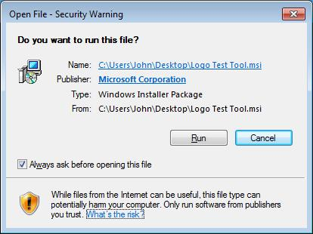

1. On the **Welcome to the Installer Wizard for Microsoft Windows (R) Logo Test Tool** page, click **Next**.

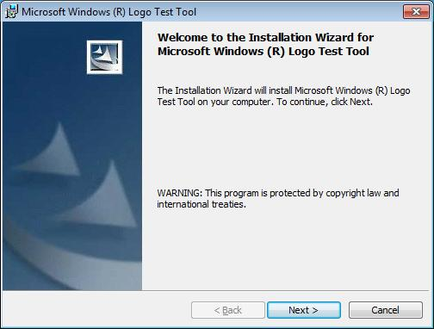

1. 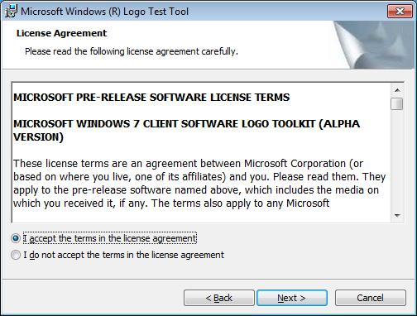On the **License Agreement** page, review the software license terms, and if you agree with these terms click **I accept the terms in the license agreement** and then click **Next**.
2. 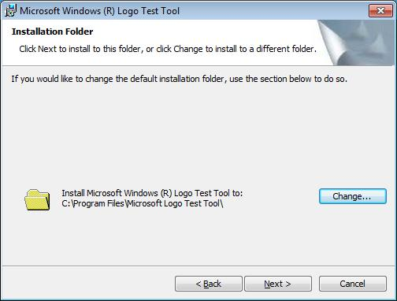On the **Installation Folder** page, review the installation location of the toolkit, and then click **Next**.

#### Note: By default, the Windows 7 Software Logo Toolkit is installed in the folder C:\Program Files\Microsoft Windows Logo Kit. Click **Change** to select a different folder and specify the new location. This document assumes that you install the Windows 7 Software Logo Toolkit in the default folder.

1. 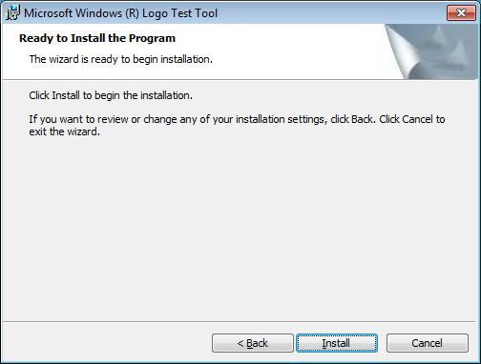On the **Ready to Install the Program** page, click **Install**.
2. 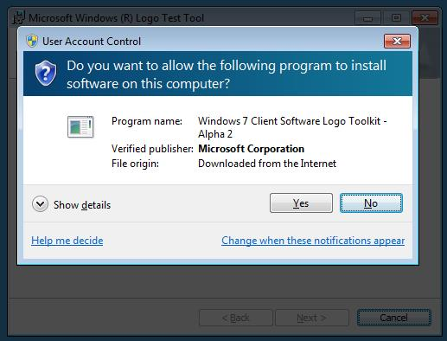If the **User Account Control** dialog box appears, click **Yes** to enable the wizard to install the toolkit.
3. Wait while the Windows 7 Software Logo Toolkit is installed.
4. 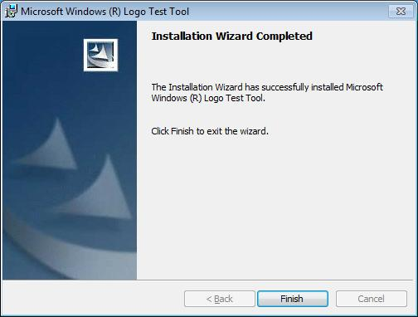On the **Installation Wizard Completed** page, click **Finish**.

#### **Note:** If you are running Windows 7 using a virtual machine, this is the point where a snapshot should be created or a copy of the VM should be made for later use.

# Testing an Application Using WSLK UI

1. Start”, then click “All Programs”, and point to 'Microsoft Windows Software Logo Kit', and then click 'Windows 7 Client Software Logo Toolkit'
2. Click **Yes** to allow the **User Account Control** dialog box to proceed
3. Select 'Validate a new application'

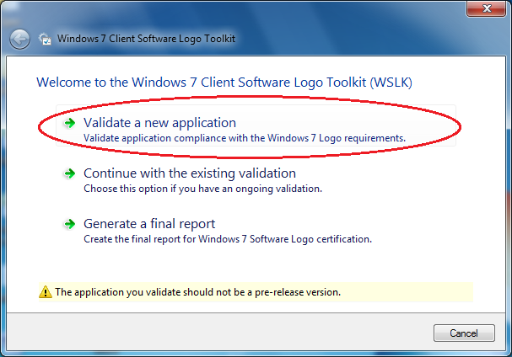

1. Select 'Start Pre-Installation'

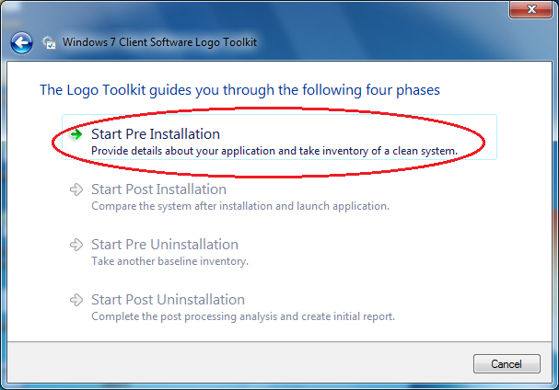

1. Leave the user interface of WSLK running in the current session
2. Click “Start”, then click the arrow next to “Shut Down”, and click “Switch User”
3. Log in to a new session using different credentials “user account”
4. In the new session, click “Start”, then click “All Programs”, and point to 'Microsoft Windows Software Logo Kit', then click 'Multi-user Session Server'. This will start the session server in a command window
5. Leave the new session running; click “Start”, then click the arrow next to “Shut Down”, and click “Switch User”
6. Log in to the first user session where the user interface of WSLK is running

#### Note**:** AppVerifier must be installed prior to commencing to the next step

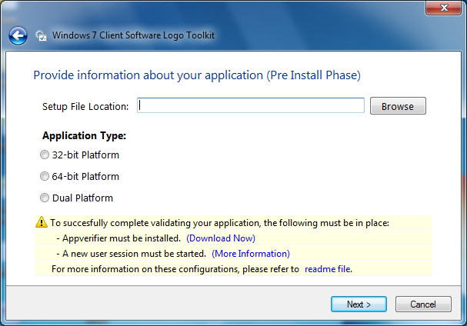

1. Install your application

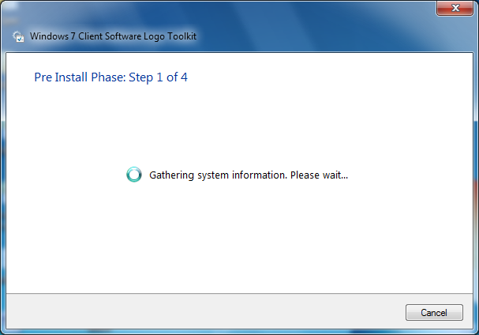

#### Note**:** Verify that your application installed correctly and continue to the next step

1. If your application installed correctly, select ‘My Application Installed Correctly’

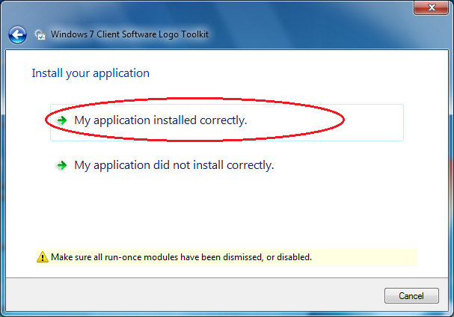

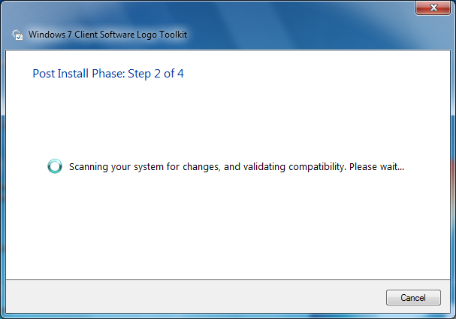

1. Click “Next”

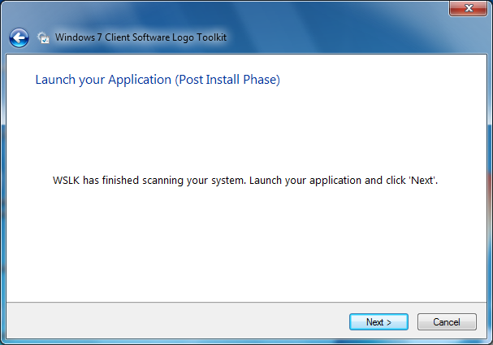

1. When you reach the 'Pre-uninstall Phase', click “Start”, click the arrow next to “Shut Down”, and the click “Switch User”

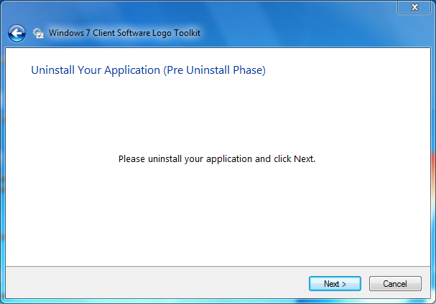

1. Log in to the other session you started in previous step
2. Close 'Multi-user Session Server' Windows any other open Windows
3. Click “Start”, then click the arrow next to “Shut Down”, and click “Switch User”
4. Log in to the first user session where WSLK is running
5. Uninstall your application, and follow the wizard to create the report

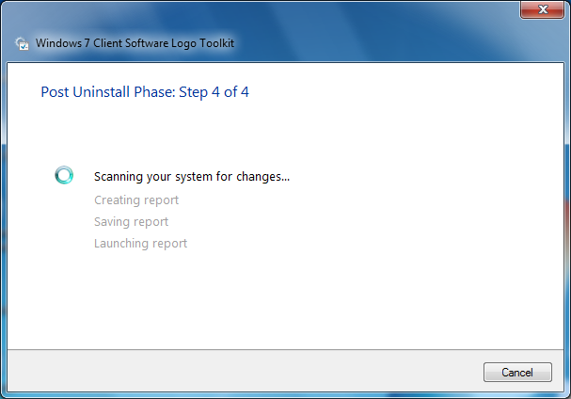

1. Select your application from the list

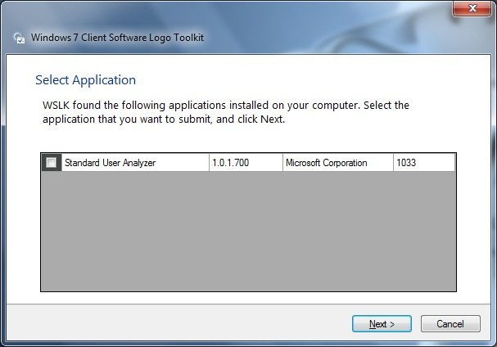

1. WSLK will internally parse validation results, upon detecting none compliance errors which maybe illegible for waivers; will prompt you enter waiver justification as outlined in the "Software Logo Requirement Document"

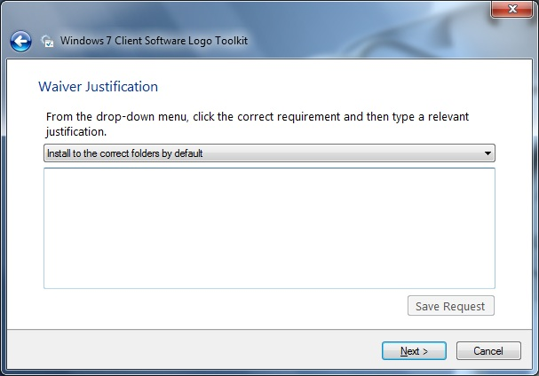

1. Submit xml report via <https://winQual.microsot.com>

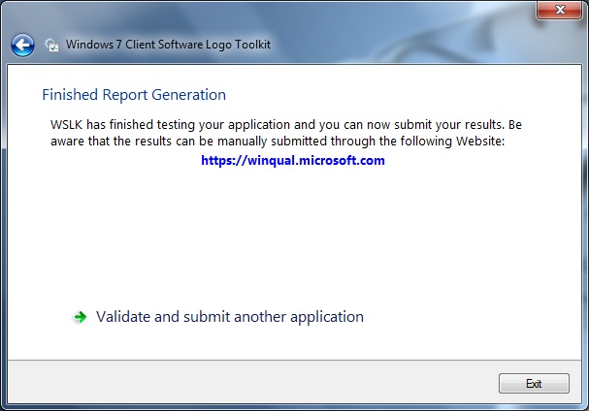

# Testing an Application Using WSLK Command Line

An application is tested to verify that it complies with the requirements of the Windows 7 Software Program by using the logo toolkit, as described in the section titled “Overview of the Software Logo Command Line Toolkit”. The topics in this section describe how to use the toolkit in greater detail.

## Before You Begin

* Start with a clean installation of Windows 7
* Install the Windows 7 Software Logo Toolkit
* Log on as an administrator
* Click the Windows **Start** button, click **All Programs**, click **Accessories**, right-click **Command Prompt**, and then click **Run as administrator**.
* 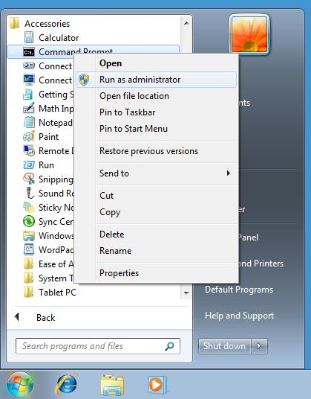Click **Yes** to allow the **User Account Control** dialog box to proceed.

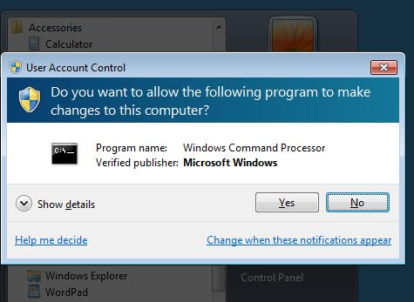

* Type cd “Program Files\Microsoft Windows Software Logo Kit” without the quotation marks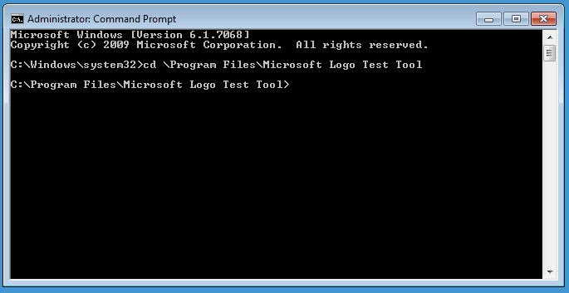

## Step 1: Take a Pre-installation Inventory of Windows 7

* Leave the Command Window running in the current session
* Click “Start”, then click the arrow next to “Shut Down”, and click “Switch User”
* Log in to a new session using different credentials “user account” with administrator rights

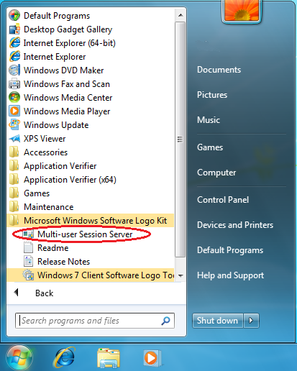

* In the new session, click “Start”, then click “All Programs”, and point to 'Microsoft Windows Software Logo Kit', then click 'Multi-user Session Server'. This will start the session server in a command window

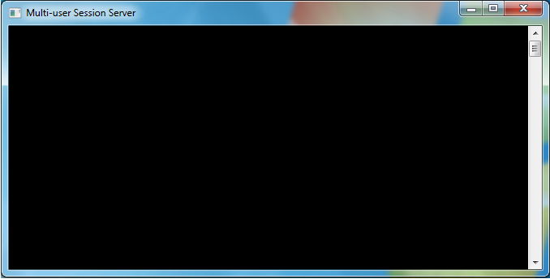

* Leave the new session running; click “Start”, then click the arrow next to “Shut Down”, and click “Switch User”
* Log in to the first user session where the Command Window is running
* If your application is a 32-bit application, in the **Administrator: Command Prompt** window, type the following command:

wslk.exe /preinstall /32bit

* If your application is a 64-bit application, in the **Administrator: Command Prompt** window, type the following command:

wslk.exe /preinstall /64bit

* If your application supports both, in the **Administrator: Command Prompt** window, type the following command:

wslk.exe /preinstall /both

### The output after running **wslk.exe /preinstall /32bit** should look like the following image:

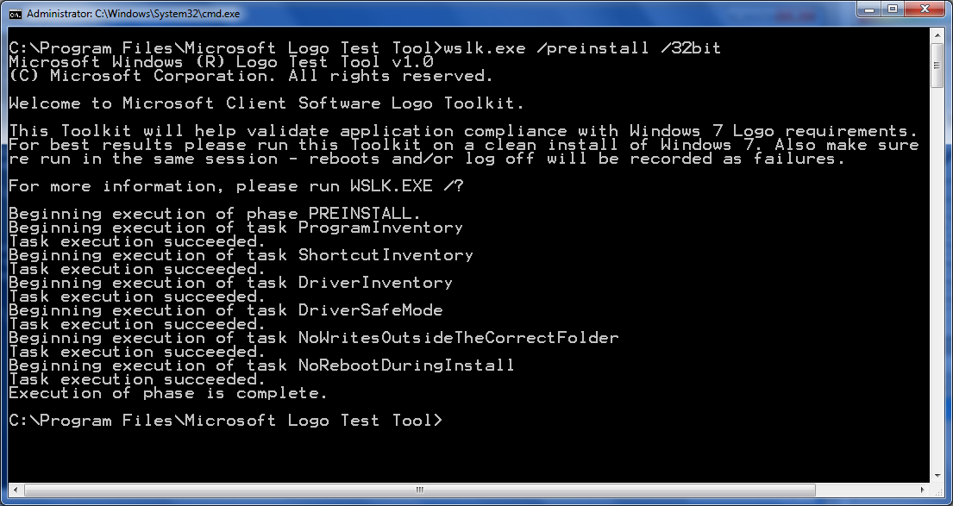

## Step 2: Install and Configure the Application

* Install the application and verify that it completes without any errors or exceptions.

#### Note**:** Any necessary application configuration, including completing any run-once or first-run execution (EULA acceptance, auto update, etc.) should be completed as part of the installation and configuration step before proceeding.

## Step 3: Compare the System State to the Preinstall Baseline Inventory

* Click “Start”, then click the arrow next to “Shut Down”, and click “Switch User”
* Log in to the other session you started in previous step
* Close 'Multi-user Session Server' Windows any other open Windows
* Click “Start”, then click the arrow next to “Shut Down”, and click “Switch User”
* Log in to the first user session where WSLK is running
* In the **Administrator: Command Prompt** window, type the following command:

wslk.exe /postinstall

### wslk3.pngThe toolkit examines the modified system state after the application has been installed. An example of the output after running **wslk.exe /postinstall** is shown in the following image. This example shows that the toolkit detected that some executables for the application are not signed.

### Note**:** The toolkit attempts to run and shutdown each of the installed executables that have shortcuts as it performs the post-installation checks.

## Step 5: Set the Pre-uninstall Checkpoint for the Toolkit

* In the **Administrator: Command Prompt** window, type the following command:

wslk.exe /preuninstall

### wslk4.pngAn example of the output of the logo toolkit is shown in the following image:

## Step 6: Uninstall the Application

* Uninstall the application and verify that uninstall completes without any errors or exceptions.

#### Note**:** The steps for performing this task are specific to the application.

## Step 7: Compare the System State and Complete the Post Processing Analysis

* In the **Administrator: Command Prompt** window, type the following command:

wslk.exe /postuninstall

### wslk5.pngThe toolkit examines the system state after the application has been uninstalled. An example of the output of the toolkit is shown in the following image:

## 

## Step 8: Generate a Report for the Application

* In the **Administrator: Command Prompt** window, type the following command:

wslk.exe /createreport AppReport.xml

#### **wslk6.png**Note**:** The second argument, AppReport.xml, is the path and filename for the XML report that is generated by the toolkit. You can specify any valid path and filename.

* Click “Start”, “All Programs”, and point to 'Microsoft Windows Software Logo Kit', and then click 'Windows 7 Client Software Logo Toolkit'

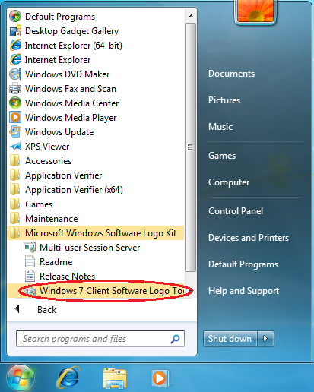

* Select ‘continue with an existing application’ and select the XML report generated in

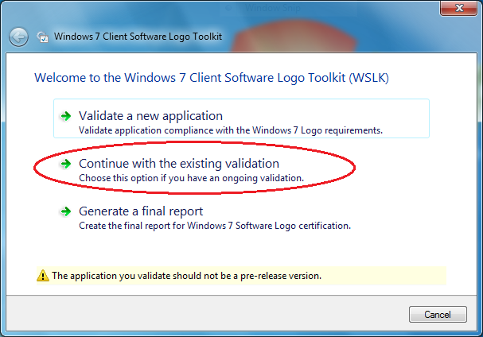

* Select the XML report generated in previous step

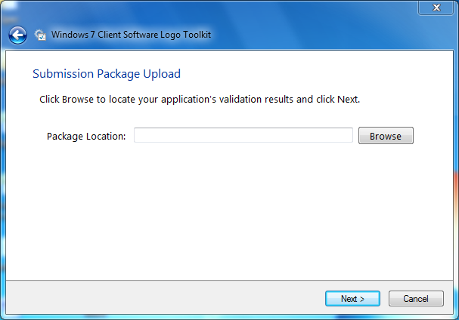

* Follow the wizard to complete the XML report
* Submit xml report via <https://winQual.microsot.com>

## Open and Review the Report

* Using Windows Explorer, browse to the **C:\Program Files\Microsoft Windows Logo Kit\** folder.

#### Note**:** If you provided and alternate path and file name when generating the report in the toolkit, then browse to that file/folder.

* Double-click the file AppReport.xml file.

Internet Explorer will start and display the report.

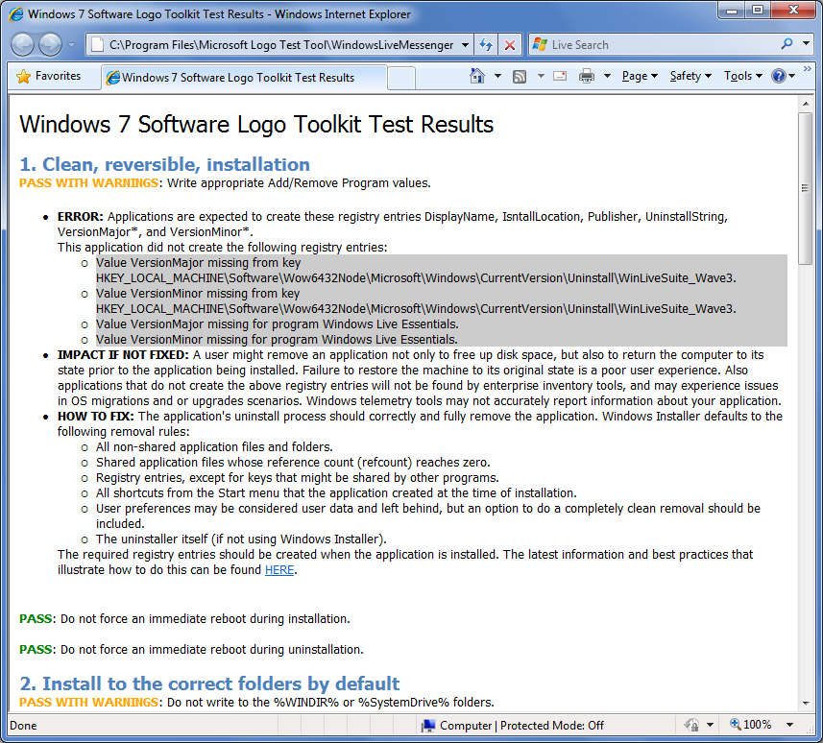

#### **Note:** there are three possible outcomes reported for each test:

#### **PASS** – no issues.

#### **PASS WITH WARNINGS** – Logo requirements have been satisfied, however there are still issues than can be addressed. An explanation of the issue, impact if not fixed, and instructions and links on how fix this issue are provided in the report.

#### **FAIL** – Logo requirement is not met. Application must be fixed and retested, or a valid waiver is necessary for this application to receive the Logo. An explanation of the failure, impact of this issue, and instructions and links on how fix this issue are provided in the report.